# Grade 2 Fractions and Place Value Worksheet

1. Colour $\frac{1}{3}$ of the **rectangle**:
2. What **fraction** of the **circle** is shaded?

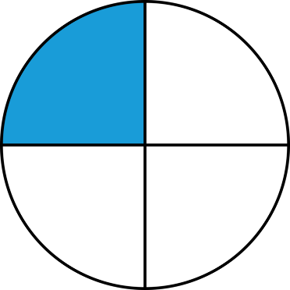

_______________________

1. Draw a **square** and show $\frac{2}{4}$.
2. Which **fraction** is **less**: $\frac{1}{2}$ or $\frac{3}{4}$?

_______________________

1. Write the **fraction** for the **orange** part:

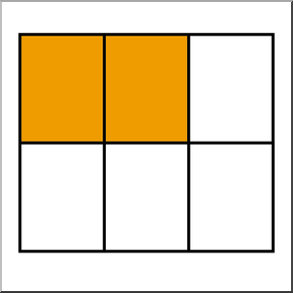

_______________________

1. 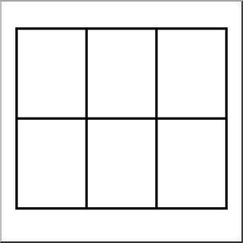**Colour** the **rectangle** to show $\frac{1}{6}$:
2. **What** is the **fraction**?

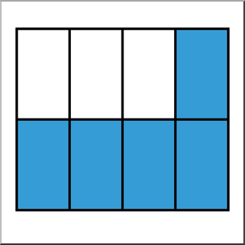

_______________________

1. **Circle** the **smallest** fraction?
$$\frac{1}{6} \frac{1}{3} \frac{1}{2}$$

2. Is $\frac{4}{4}$ equal to **1**? **Yes** or **no**?

_______________________

1. What is $\frac{1}{3}+\frac{1}{3}$?

_______________________

1. Write the number: **7 hundreds, 4 tens and 1 ones**.

_______________________

1. What is the value of the **5** in **653**?

_______________________

1. Which is the **smallest**?

492, 406, 531, 319

______________________

1. What number comes **before** **675**?

_______________________

1. Write the number that has **9 hundreds, 0 tens, and 8 ones**.

_______________________

1. How much is the **8 in 428**?

_______________________

1. What is in the **tens** place of **709**?

______________________



1. Solve: **200 + ? = 600**

_______________________

1. Write the number that has **2 hundreds, 6 tens, and 9 ones**.

_______________________

1. Compare using **>, <, or =**:

385 _________ 583

1. Count **+2** starting from **16** to **30**.

16, ____________________________, 30

1. What comes **after 72** when counting **+5**?

_______________________

1. Count **backward** **-10** from **100** to **40**.

100, ____________________________, 40

1. **Fill** in the **missing** **numbers**: **35, __, 39, __, 43** (**+2**)

___________, ____________

1. Count **+3** starting from **63** to **75**.

63, ____________________________, 75

1. What is **28 + 4 + 4 + 4 + 4**?

_______________________

1. Count **forward** **+10** from **70** to **120**.

70, ____________________________, 120

1. What comes **before 81** when counting **-9**?

_______________________

1. Count **backward** **-5** starting from **50** to **30**.

50, ____________________________, 30

1. **Fill** in the **blanks**: __, 18, __, 22, __, 26 (**+4**)

_________,__________,________